**980 PRO w/ Heatsink PCIe® 4.0 NVMe® SSD 1TB**

**MZ-V8P1T0 /MZ-V8P1T0CW**

4.9 out of 5 stars, average rating value. Read 151 Reviews. Same page link.

4.9

(151)

Write a review

Share your product experience

* • True PCIe® 4.0 NVMe™ speed (up to 7,000 MB/s for seq. reads,  5,100MB/s for seq. writes)  
    
  •  Ideal for heavy computing, high resolution graphics and PC gaming.   
    
  • For console gaming, compatible only with Playstation® 5.

**Storage**

**[1TB](https://www.samsung.com/us/computing/memory-storage/solid-state-drives/980-pro-w-heatsink-pcie-4-0-nvme-ssd-1tb-mz-v8p1t0cw/" \t "_self)**

[$119.99](https://www.samsung.com/us/computing/memory-storage/solid-state-drives/980-pro-w-heatsink-pcie-4-0-nvme-ssd-1tb-mz-v8p1t0cw/" \t "_self)~~[$164.99](https://www.samsung.com/us/computing/memory-storage/solid-state-drives/980-pro-w-heatsink-pcie-4-0-nvme-ssd-1tb-mz-v8p1t0cw/" \t "_self)~~

**980 PRO w/ Heatsink PCIe® 4.0 NVMe® SSD 1TB$119.99**



**In-Store Pickup:Select Store**

Pickup unavailable for this ZIP



**Delivery for:96928**

Delivery unavailable for this ZIP

Total

**$119.99**~~$164.99~~

You Saved Today**$45.00**



**Log in to earn up to 3 points per $1**

[**ADD TO CART**](javascript:;)

Supported payment types:

Credit Card

Compatibility

Thermal protection

Interface

7,000 MB/s Sequential Read Speed

**Next-level performance  
with maximum heat control**

Unleash the power of the Samsung 980 PRO with Heatsink for next-level computing and gaming. With a PCIe®4.0 NVMe™ interface, get up to 2x the data transfer rate of PCIe® 3.0\* while remaining compatible with PCIe® 3.0.  
  
The integrated heatsink disperses heat to maintain speed, power efficiency, and thermal control, preventing downtime from overheating on Playstation® 5 and PCs.

*\* Results are based on a comparison with Samsung PCIe® 3.0 NVMe SSDs and SATA SSDs.*



**Top Speed**

Get read speeds up to 7,000 MB/s¹ with 980 PRO with Heatsink and push the limits of what SSDs can do. Powered by an in-house controller designed to harmonize the flash memory components and the interface for top speed – with a PCIe® 4.0² interface that’s 2x faster than PCIe® 3.0 SSDs³ and 12x faster than Samsung SATA SSDs⁴ – every component of this NVMe™ SSD is manufactured by Samsung for  
performance that lasts.

*1 Performance may vary depending on the SSD’s firmware version and the system hardware & system configuration. Performance measurements are based on IOmeter 1.1.0. The write performances were measured with Intelligent TurboWrite technology being activated.*

*2 To maximize the performance of the 980 PRO, please check whether your system supports PCIe® 4.0 at the Intel or AMD website.*

*3 Results are based on a comparison with Samsung PCIe 3.0 NVMe SSDs and SATA SSDs.*

*4 Test system configuration: AMD Ryzen 9 3900X 12-Core Processor CPU@3.79GHz, DDR4 2666MHz 16GBx2, OS-Windows 10 Pro 64bit, Chipset-ASUS-X570-ROG CROSSHAIR VIII FORMULA*

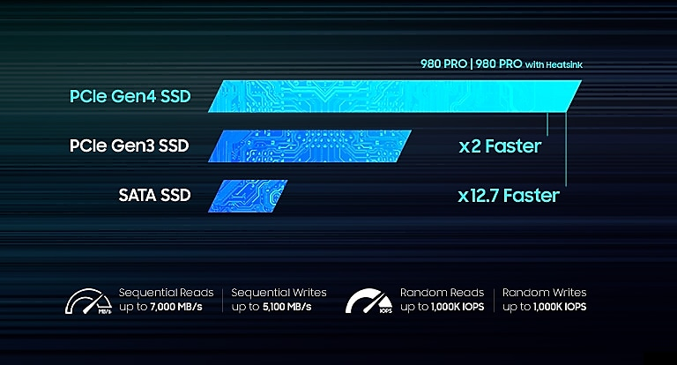

**A winning combination**

The 980 PRO with Heatsink delivers an additional layer  
of thermal control for smart heat management to reduce heat. Achieve fully immersive gameplay with sustained high-performance bandwidth and throughput for heavy-duty applications in gaming, graphics, data analytics, and more. Load games fast, so you can play more and wait less.



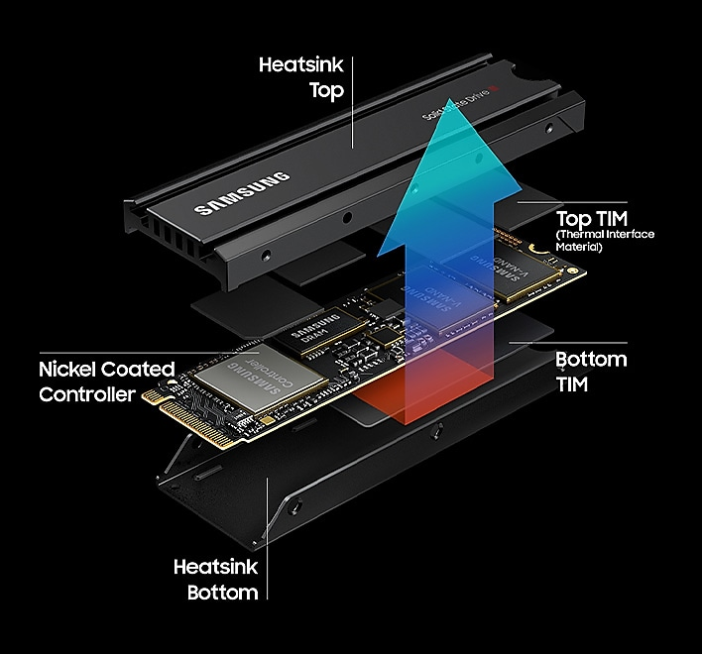

**Smart thermal control**

High-performance SSDs require high-performance thermal con